Word Study (and Dolch Words) in Second Grade

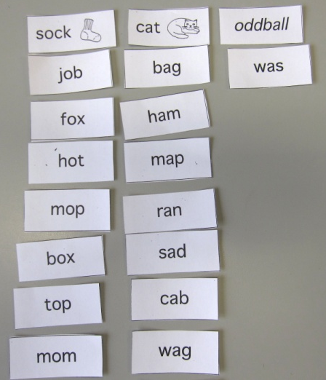
I would like to help you understand what Word Study looks like in second grade. There are two types of words that your child will be learning to spell: Word Study words and Dolch words.

Word Study Words
Each week your child will be given twelve Word Study words to learn based on the spelling pattern his/her individual group is studying in class (groups are created based on assessment results). He/she will learn the “rules” associated with each pattern and will take part in “word work” activities throughout the week to gain more exposure to the pattern and practice making and sorting words that follow the pattern. Students will also practice nightly with Word Study homework that requires them to sort the words, read them aloud, and then perform a specific task as follows:

- Monday – Sort the words into categories (for example, CVC (consonant/vowel/ consonant) – short “a” short “o”). Read each word aloud and write each word under its header.
- Tuesday – Sort the words. Read each word aloud, write each word under its header, and underline the vowels (a, e, i, o, u).
- Wednesday – Sort the words. Read each word aloud then pick 6 words and write a complete sentence for each word.
- Thursday – Sort the words. Read each word aloud then put the words away. Have an adult give you a practice test of all your words (the adult will say the word the student will write it under the correct header).

Note: Every night, students will also write down all five of their Dolch words under the header Dolch, and read each word aloud.

An assessment will be given each Friday morning and will include some words that your child will not be able to study – words that follow the same spelling pattern.

Ten words will be words that they have been studying all week, and five words will be new words that follow the pattern studied. This will help me assess how well each student can apply the spelling pattern to different words instead of only assessing how well they can spell isolated words that may have been memorized for the test.

Research has shown that students often memorize words for a test and then quickly forget them the following week, and that using the Word Study approach to spelling leads to more accurate spelling of words when students are composing their own pieces of writing. This is because students are studying the phonics, the sounds that letters make within the words rather memorizing the spelling of words in isolation.

Dolch Words
There are specific words in the English language called Dolch words. The Dolch word list was compiled by Edward Dolch based on the most common words used in children's books. The list contains 220 words that must be quickly recognized in order to achieve reading fluency (the ability to read a text accurately, quickly, and with expression). These words make up 50-70% of ANY general text.

Unlike Word Study words, many Dolch words often don’t follow a spelling pattern, can't be "sounded out," and have to be learned by "sight" (memorized).
In second grade, the goal is for each child to be able to read and spell ALL of the words on the Dolch Word List through the second grade level (the list is divided by grade level through third grade). Repetition and practice are very important in making recognition of these words automatic. Once Dolch words have been memorized, children read more fluently and with greater comprehension, and their writing often improves.
Each week the children will be assigned five Dolch words to learn. As with Word Study words, they learn these words through "word work" activities in the classroom, and will write them down and read them aloud nightly.

Dolch words will be part of your child’s Friday spelling assessment. The assessment will contain 20 words. Fifteen of the words will be their pattern-based Word Study words, and the remaining 5 will be Dolch words. Your child will be expected to spell the Dolch words correctly as part of a dictation portion of the weekly spelling assessment.

Dictation gives students an opportunity to use their spelling skills in a “real world” application. It requires them to use their listening skills and allows them to concentrate on the writing and spelling process without having to compose original sentences. Dictation benefits students in a number of ways. It…

- focuses their attention on listening, strengthening their listening skills.
- gives them the chance to practice newly learned words in context.
- reviews words they already know how to spell in a meaningful way.
- helps move them from the easier task of simply spelling a word to the more difficult task of independently writing a sentence using the newly learned word(s).

